Patient Triage Template Policy
Version: | Review date: | Edited by: | Approved by: | Comments:
V1 | July 2022 |  | W Povey | New Process live on 21/-7/2021

Introduction
Stockport Medical Group will use Patient Triage as an Online Consultation platform. Patient Triage enables patients to report medical issues, submit an administrative request, and seek self-help guidance. The practice usually triages the request and responds within a stated timeframe. This protocol outlines appropriate use of the service and how it is embedded in the running of the practice.

How does Patient Triage work?
Patients access Patient Triage via a link on the practice's website. accuRx provide the url for this link to the practice, for them to display on their website. When the patient clicks on this link, this opens a webpage which offers the patient the ability to:
- Seek self help - this links to NHS guidance
- Submit a medical request - patients are asked a few short generic questions.
- Submit an admin request - patients are asked questions specific to their request type
Before submitting, the patient must enter their contact information, which allows them to be found on the Patient Demographic Service (PDS), and - if found - this will link the request to the relevant patient on the practice's EPR. Requests come into the accuRx toolbar, via the inbox. They can be saved to the EPR with one click and assigned to different teams / individuals. Staff can respond to requests using the accuRx suite of SMSs and video calls.
The practice can review data on usage. This article explains how: https://support.accurx.com/en/articles/4328408-patient-triage-how-to-see-how-many-requests-you-have-received-and-which-type

What safety features are there?
- Patients are advised that Patient Triage is not for urgent queries, as requests might not be seen by the practice for a number of working days - this number can be customised by the practice (this article explains how: https://support.accurx.com/en/articles/4342024-patient-triage-how-to-change-your-response-time).
- Patients are directed towards 111 or 999 services for more urgent requests, and there is a customisable option to switch on an 'out of hours' message, which directs patients to local out of hours services outside of 08.00 - 18.00h, weekends, and Bank holidays. (This article explains how to switch on the ‘out of hours’ messaging: https://support.accurx.com/en/articles/4575152-patient-triage-out-of-hours)
- Before submitting a medical or admin request, patients must confirm they have no 'red flag' symptoms. If they do, they are advised to seek more urgent medical attention, and they cannot proceed to submit a request
- Upon submission, patients are reminded that the practice may not see their requests for the defined amount of time, and advised to seek more urgent medical attention if they deteriorate

Benefits to the practice
- More efficient: patient queries can be dealt with more quickly, and by the right person.
- Fewer wasted appointments: patients can be signposted to the right person and service before the appointment is made
- Saves clinician's, admin's, and patient's time: when the request comes into the practice, it's quick to read, and understanding the problem before speaking to a patient allows clinicians to get to the heart of the matter quickly, and look up relevant information before responding. Many admin requests can be dealt with without seeking more information from the patient.
- Patient Triage integrates with SystmOne and EMIS - so requests can be saved straight into record with one click
Benefits to Patients
- Easy to access: no app, no account needed - patients simply go to the webpage
- Faster: requests are quick and simple to submit, and no need to wait on hold over the phone

Responsible individuals
Wendy Povey is responsible for overseeing the use of Patient Triage at the practice, embedding use within normal ways of working and using the service to improve patient care and experience. Any questions and concerns should be directed to them. Diane Wolstenholme and Gail Annable are responsible for ensuring that all staff are trained to use Patient Triage.

Set up and launch
Stockport Medical Group will go live with Patient Triage on Wednesday 21st July 2021.
Wendy Povey is responsible for ensuring all staff are aware of this date, and have been trained to use it.

Practice website
The practice website will be reviewed by Wendy Povey to identify all relevant access points to which the link should be added. Key access points include direct links to appointments, fit-notes, test results, and repeat prescriptions. Reference to 'accuRx' should be avoided, to lessen the risk of patients mistakenly contacting accuRx. This article gives some examples of where to put the link - https://support.accurx.com/en/articles/4354819-updating-your-website-with-patient-triage.
Suggested wording:
"You can contact us about a medical, administrative or prescription issue by clicking herehttps://florey.accurx.com/p/P88632. Answer a few short questions and we will get back to you within 3 working days, medical requests will be reviewed within 24hrs. Please do not use this online form for urgent or emergency requests. The submitted forms will only be read during office hours. The forms will not be read on the weekends (Saturdays and Sundays) or on bank holidays. They will not be read Monday-Friday between the hours of 5pm – 8am. Please contact 111 during out of hours or 999 if this is an emergency."

Phone Message
The phone message for on-hold and out of hours will be updated to direct patients to use Patient Triage.
Suggested message:
"You can now submit non-urgent medical or administrative requests through our website. Please visit www.stockportmedicalgroup.co.uk to find out more."

Additional Patient Communication
Patients will be alerted to Patient Triage via:
- [Posting on the practice website]
- [Posting on social media]

Training and familiarisation
Patient Triage has been designed to be simple and intuitive therefore training should be minimal, however all staff should familiarise themselves with the software by submitting a medical and an administrative request as a 'test' patient. There is a step-by-step guide on how to manage patient requests submitted to the practice via Patient Triage in this article (https://support.accurx.com/en/articles/4410732-patient-triage-how-to-manage-patient-requests-in-the-accurx-inbox.) To see how patient triage works purely from a patient's perspective (and without submitting the request to the practice), you can do that using this demo version (https://florey.accurx.com/p/demo).
Monthly practice meetings will also be used to demonstrate any new features or templates. All new staff will also have a brief introduction to Patient Triage and the time to familiarise themselves as part of their induction.
Reception staff are encouraged to direct patients towards Patient Triage, or fill in the webform on behalf of patients who cannot do it themselves.

Matching capacity to demand
The NHS toolkit (https://future.nhs.uk/system/login?nextURL=%2Fconnect%2Eti%2FDigitalPC%2Fviewdocument%3Fdocid%3D66209701%26fid%3D18991760) can help map capacity to demand. 'Patient Triage Usage' under 'Manage Practice' will give data about what type of requests come in, and when, to help monitor demand. This article (https://support.accurx.com/en/articles/4328408-patient-triage-how-to-see-how-many-requests-you-have-received-and-which-type) explains how to view your usage for Patient Triage.

Patient safety
All practice staff should be aware that:
- Patients may submit urgent medical issues despite being warned not to.
If a request that seems urgent is received, staff monitoring the inbox should alert Duty GP by adding to the Duty GP urgent list for action.
- Patients may submit inappropriate photos despite being warned not to.
If a request that seems inappropriate is received, staff monitoring the inbox should alert the Duty GP by adding to the Duty GP urgent list for action.
- Patients may submit incorrect prescription requests.
The request is free-text, and therefore may be open to patient error in both medication name and/or dosage. Staff completing medication requests from Patient Triage must be aware of this possibility, and cross-check medications and dosages. Patients can be prompted to use other customisable prescription services under the Manage Practice settings (this article explains how to set this up - https://support.accurx.com/en/articles/4435020-patient-triage-how-to-redirect-patients-to-an-existing-repeat-prescriptions-service).
- Unregistered patients can submit a request.
Because we have made Patient Triage easy for patients to access, anyone can submit a request, even if they are not registered at your practice. Patient Triage makes it mandatory for the patient to provide a valid phone number when submitting a request - the practice will contact the patient to alert them to the fact they are not registered, and ask them to contact their registered practice.
- Requests may not be from the patient
When the request indicates 'patient not found', the onus is on the practice to confirm the patient’s identity. Staff should understand the different matching states, below, and be alert to the possibility of a sensitive request from a 'not found' patient. It may be necessary to take extra steps to confirm the patient's identity before saving the request to the record.

When patients submit requests through Patient Triage, they give their:
- Name
- date of birth
- gender and
- postcode
These details are then used to search the Patient Demographic Service (PDS) - the NHS database of patients and look for a specific patient who matches these details.
They also enter a contact number. If they provide a mobile number and they confirm they are in possession of the mobile at the time of submitting a request, they are sent a code by text message which they are then asked to confirm on the online form. This is called '2 factor authentication' and is similar to security controls put in place for online banking. 2 factor authentication shows that whoever fills in the online form has access to the same mobile phone as that listed on their PDS record.
If the details that the patient submits match exactly to an entry on PDS (registered to the practice) and they have been able to show that they are in possession of the mobile phone number (by passing the 2 factor authentication process), the patient has proven their identify. These patient requests will be returned to the accuRx inbox matched to the patient. These requests can be saved directly to the patient's medical record.
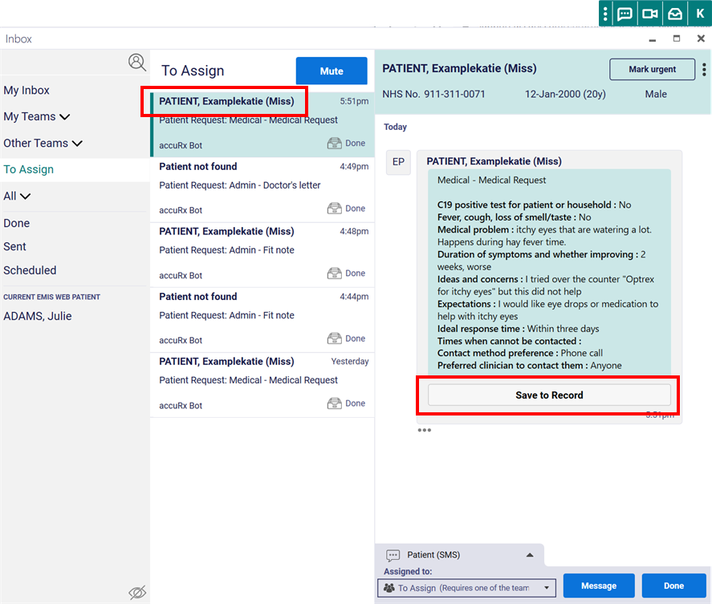

Sometimes patient requests will appear in the accuRx inbox as "Patient not found". There are 2 reasons this might happen:

- The patient was unable to complete the mobile phone verification

If the patient's details match exactly to a patient on PDS that is registered at the practice but they have not passed 2FA then the request will appear as "Patient not found" in the inbox with a suggestion of who the patient request might belong to.

There could be a number of different reasons why a patient was unable to complete mobile phone verification such as:
        - The patient did not have their mobile phone on them at the time of submitting the request
        - The mobile phone number that was given was different to that on the medical record
        - The patient gave a landline number
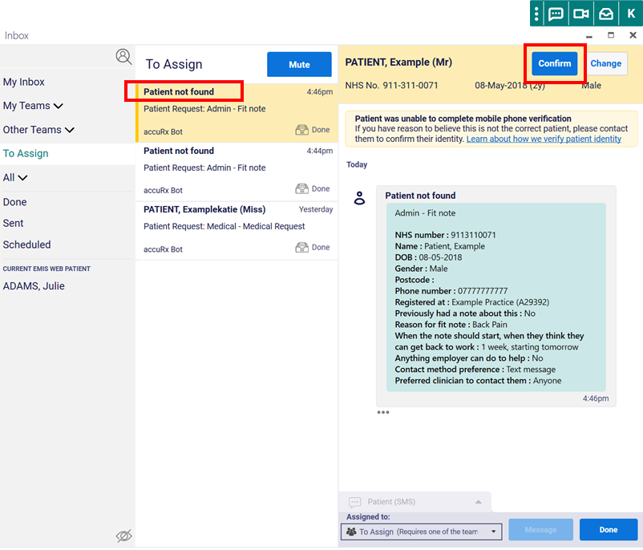

- The details that the patient submitted didn't match exactly to a patient on PDS that is registered to your practice

If no unique patient registered to the practice is found on PDS with the information that has been submitted, the patient request will appear with no suggested patients linked to it.
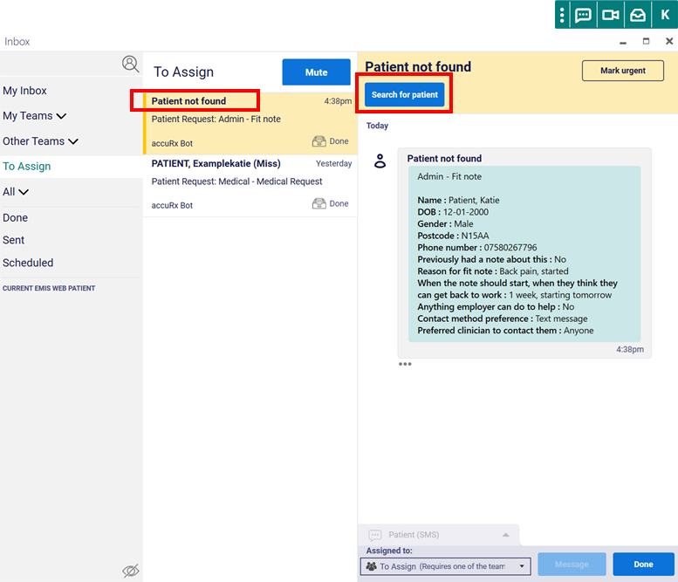

Requests from patients 'not found' can be manually linked to an existing patient if it is deemed appropriate to do so, as described in this article (https://support.accurx.com/en/articles/4410732-patient-triage-how-to-manage-patient-requests-in-the-accurx-inbox).

Support
Most support questions can be answered by visiting support.accurx.com, and this should be attempted in the first instance. If an issue remains unresolved, users can email support@accurx.com, use the Live Chat at www.accurx.com

Information Governance, Security, and GDPR
As the data controller Wendy Povey takes on the responsibility for completing a DPIA for Patient Triage. See template DPIA (https://docs.google.com/document/d/1uMYp-k7Hls3J5Mg7o8rk_9CgQnqHJBI9cxz47M7IsoQ/edit?usp=sharing).

accuRx is an NHS Digital approved supplier (https://digital.nhs.uk/services/future-gp-it-systems-and-services/gp-it-system-suppliers-awarded-contracts), and also specifically an NHS Digital approved online consultation supplier (https://buyingcatalogue.digital.nhs.uk/solutions/covid19/10030-001). They have Data Security and Protection Toolkit assurance (https://www.dsptoolkit.nhs.uk/News/34) (ODS code: 8JT17), and have the Cyber Essentials Plus certification (https://www.cyberessentials.ncsc.gov.uk/cert-search/?query=accurx).

Continuous improvement
To fully embed Patient Triage as a way of working, and maximise the benefits for the practice, staff and patients Diane Wolstenholme is responsible for leading improvement initiatives, and other staff are strongly encouraged to participate. These include:
- Practice meetings – for example presenting usage across the team and asking top users to share how they use it
- PPG meeting – gathering patient feedback on the service and identifying other opportunities to provide a better patient experience using Patient Triage
- Audits – running reports to understand how requests are being handled, and in particular whether efficiencies are made, such as number of appointments saved

